**(ADDED TO PAPER)**

**Fire alarm batteries**

The battery that would be best for this SMART fire alarm system would be a 9V 1200mAh Lithium battery. The Ultra life 9V Lithium Battery is the perfect battery for low drain devices. Also, this battery has a long duration of shelf life at about 10 years, which is great for the fire alarm system. A long shelf life would help the fire alarm system be more reliable, and it will also require less maintenance. There are different types of batteries that we could use, alkaline or lithium batteries. As stated before, we chose to go with a lithium battery rather than an alkaline battery. When comparing the two different types of batteries we and see the difference between the two, and how we came to make this decision.

**Shelf-life**

When it comes to shelf life, we chose to go with the lithium battery because lithium batteries can last much longer than an alkaline battery can. As mentioned above a longer shelf live requires less maintenance to be done with the smoke detectors, other than routine checks to make sure that everything is up to code. Therefore, requiring less maintenance allows the customer to not have to change the battery so often.

**Performance**

Lithium batteries work well with devices that are low drain and high drain, whereas alkaline batteries don’t perform well with high drain devices, unless they are a special premium alkaline battery. Alkaline batteries are good batteries, just not for a smoke detector, a major problem with these types of batteries is that they are susceptible to self-discharging. This leakage could damage the device which could cause the smoke detector to malfunction and not go off which would endanger a lot of people. Lithium batteries are said to last about 7x to 8x longer than alkaline batteries. Also, it is mentioned that lithium batteries can withstand lower or higher temperatures depending on the environment that batteries are placed in. Opposed to alkaline batteries that can’t perform in those types of environments.

**Cost**

The upside that we found with the alkaline batteries is that they are very low cost, compared to lithium batteries, and you can get them in bundles for cheap as well. Lithium batteries are usually at least twice the amount of alkaline batteries. However, even though the lithium batteries are more expensive the quality of them are better and they outperform and outlast most other batteries. So, spending the extra money to purchase these types of batteries would be worth it so we could provide our customers with the best quality product.

**Power and Capacity**

Lithium batteries usually produce twice as much voltage as alkaline batteries produce, which allows them to outlast and have a longer shelf life as alkaline batteries. As mentioned above the Ultra life 9V lithium battery that we chose will have a max capacity rate of 1200mAh. Most alkaline 9V batteries don’t produce a max capacity rate of 1200mAh. Most of the alkaline batteries, besides the special premium types, produce around a max of 800mAh. With the lithium battery having a higher capacity rating than the alkaline battery this proves that the lithium battery will deliver a longer performance than the alkaline battery, which is what we want to provide a best quality product.

**Fire alarm sound and signaling**

Per the National Fire Protection Association (NFPA 72) code, the audibility of the alarm varies depending on the type of environment the alarm system is in. For a public place the minimum audibility of the alarm must be 15dBA above the average ambient sound level, and for a private place the alarm cannot be less than 10dBA above the average ambient sound level. This is just one type of requirement for the audibility. Another one that pertains to both of the types of places is that the minimum requirement of sound from the alarm must be 5dBA above the max sound barrier with a duration of at least 60 seconds. Also, stated within the NFPA 72 code is that the maximum output audible sound the fire alarm system can have is 110dBA. This output is based upon the minimum hearing distance.

Based on the code requirements from the Nation Fire Protection Association, we could use this as reference guide in determining the type of component we will use for the fire alarm. As mentioned above the NFPA 72 code depending on the type of environment the system is in the audible sound level should either be 10dBA or 15dBA above the ambient noise level, or 5dBA for 60 seconds above the maximum level; with the alarm system being at a distance that is 5ft above the floor level. Table 1.1 shows the different locations, the average ambient noise level the minimum corresponding dBA level for an alarm system.

**Table 1.1**

|  |  |  |
| --- | --- | --- |
| Locations | Average ambient noise level (dBA) | Minimum required for SPL (dBA) per location |
| Business offices | 55 | 70 |
| Industrial occupancies | 80 | 95 |
| Institutional occupancies | 50 | 65 |
| Mechanical rooms | 85 | 100 |
| Places of assembly | 55 | 70 |
| Residential places | 35 | 50 |
| Storage occupancies | 30 | 45 |
| Thoroughfares, high-density urban areas | 70 | 85 |
| Thoroughfares, moderate – density urban areas | 55 | 70 |
| Thoroughfares, rural and suburban areas | 40 | 55 |
| Underground structures and windowless buildings | 40 | 55 |
| Educational occupancies | 45 | 60 |
| Mercantile occupancies | 40 | 55 |
| Piers and water-surrounded structures | 40 | 55 |
| Tower occupancies | 35 | 50 |
| Vehicles and vessels | 50 | 65 |

This table is in accordance with NFPA 72.

**Sounders**

When picking the type of sounders, we want to make sure we can reach a wide range of locations based off the min amount of audible sound. Per Chapter 18 of the NFPA 72 code the implementation of low frequency of 520 HZ must be used in in sleeping areas. So, to be able to comply with this code we wanted to make sure that we chose a sounder that would be able to work between a good range of frequencies that would cover both sleeping areas and normal occupancies. From this research, we came across many different types of sounders, but we narrowed it down 4 different types. Three are Piezo sounders and one is PUI programmable buzzer.

* **PS1927P02 Piezo sounder**

This sounder is a high sound pressure buzzer with a maximum SPL at 90dBA/10cm min at 2.7 kHz, at 10Vp rectangular wave. This sounder has a maximum input voltage at 20Vp (without a DC bias). Table 2.1 shows a graph of the sound pressure corresponding to frequency.

**Table 2.1**

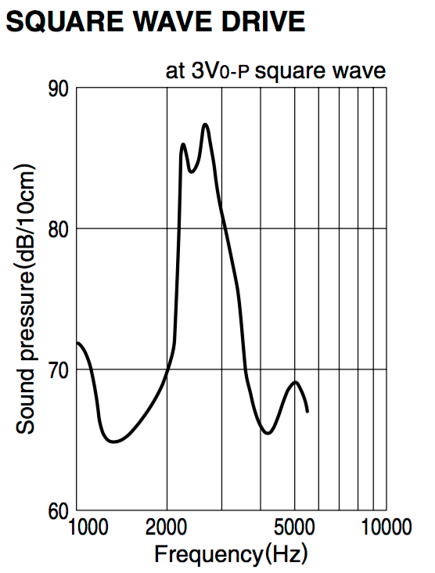

We considered this Piezo buzzer because the sound pressure level was high enough to where it would work in different types location specified in table 1.1. Also, the cost of this buzzer was cheap and would work with the budget. However, the SPL was only high between 2kHz and 3.5kHz, where at lower and higher frequencies the SPL was lower. So, this type of sounder didn’t give us a wider range frequencies to work with than the other buzzer types.

* **PS1920P02 Piezo sounder**

This sounder is a low frequency tone buzzer with a maximum SPL at 80dBA/10cm min at 2 kHz, at 10Vp rectangular wave. This sounder has a maximum input voltage at 20Vp (without a DC bias). Table 2.2 shows a graph of the sound pressure corresponding to frequency.

**Table 2.2**

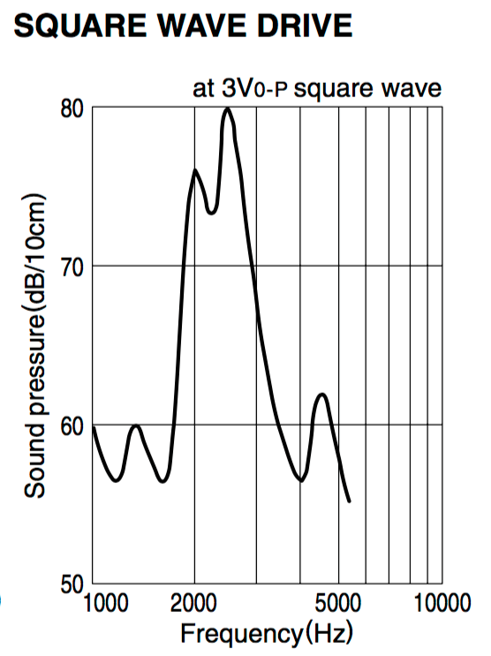

We considered this Piezo buzzer because the sound pressure level was high enough to where it would work in different types location specified in table 1.1. Also, the cost of this buzzer was cheap and would work with the budget. However, the SPL was only high between 2kHz and 3kHz. Also, this sounder had one of the lowest sound pressure level at the lower frequency than the other four sounders. As well as a low SPL at high frequencies. So, this type of buzzer didn’t give us a good range of frequency we could reach and still have a decent SPL that would work for different environments.

* **PS1740P02E Piezo sounder**

This sounder is a high sound pressure buzzer with a maximum SPL at 75dBA/10cm min at 4 kHz, at 3Vp rectangular wave. This sounder has a maximum input voltage at 30Vp (without a DC bias). Table 2.3 shows a graph of the sound pressure corresponding to frequency.

**Table 2.3**

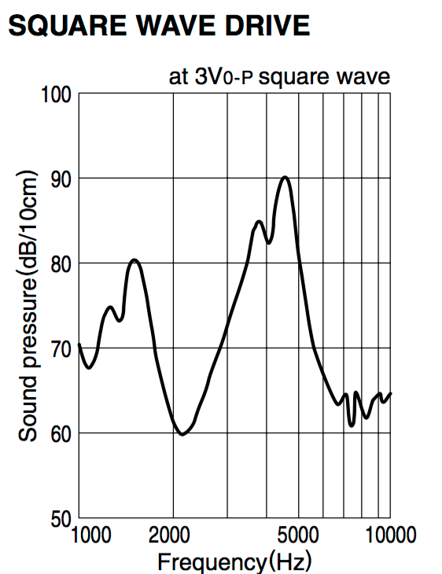

We chose this Piezo buzzer because the sound pressure level was high enough to where it would work in different types location specified in table 1.1. Also, the cost of this buzzer was cheap and would work with the budget. The frequency range that comes with this sounder is very broad which works well for this system. This sounder has a good sound pressure level with lower frequencies, which is good for private occupancies. As well as, a good sound pressure level with the higher frequency range that is good for public occupancies. Another reason as to why we chose this sounder is that the frequency gap where the SPL was really low was smaller between the other buzzers. So this sounder met a lot of specifications we needed so that is why we chose this one.

* **12 VDC PUI programmable buzzer**

This sounder is a high sound pressure buzzer with a minimum SPL at 100 dBA/10cm min at 1 kHz. This sounder has an operating voltage ranging from 7 – 24 Vdc, as shown as in the table below. Table 2.4 shows a specification table of the programmable sounder.

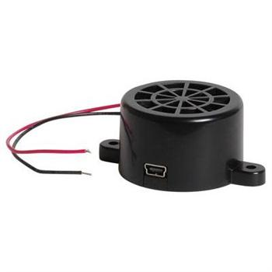

**Table 2.4**

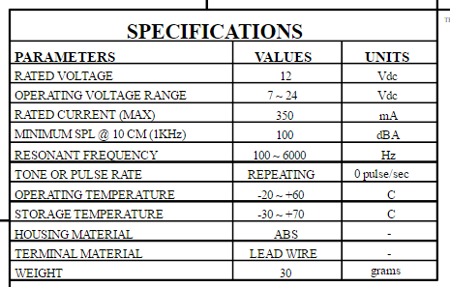

We consider this 12Vdc PUI programmable buzzer because the sound pressure level was high enough to where it would work in different types location specified in table 1.1. However, the cost of this buzzer was a lot more expensive than the other buzzer that we were considering, so due to the cost it would increase our budget more than we wanted it to, because we would need to buy several of them for the fire alarm system. The great thing about this buzzer is that it’s adjustable so we would be able to change the different types of sounds that it makes, and we would be able to adjust the sound pressure level. Even though the cost was high, the frequency range that comes with this sounder is very broad, as shown in the table above the resonant frequency range is from 100 Hz to 6 kHz; which works very well for this system. This sounder has a good sound pressure level with lower frequencies, and since it is adjustable it would work for private occupancies. As well as, a good sound pressure level with the higher frequency range that is good for public occupancies. So even though this sounder met a lot of specifications we needed, the cost and the SPL was a little bit too high for the use.